
Module Name/Code: | Cyber Security/COM5406
Student 1: | Daniel Kolasinski, Code and Security Lead, 2505493
Student 2: | Adeena Fayyaz System, Hardening lead, 2328016
Student 3: | Howard Wai, Governance and Risk Lead, 2307140
Student 4: | Maduabuchi Victor Orizu, Network and Threat Modelling Lead, 2416459
Tutor/Lecturer: | Bren Tighe
Assignment Title:  Artefact Title: | Bee Pies & Pasties – Post-Incident Security Investigation  Investigative analytical report of BarmBuzz attack, evidenced with finds of business operations and handling
Submission | Deadline: 29/05/2026:
Course/Programme: BSc (Hons) Computing/BEng (Hons) Software Engineering.

- Analyse common security threats and vulnerabilities in software and system configurations, prioritising associated risks.
- Evaluate a system's overall security position and propose effective technical and/or policy improvements aligned with best practice.
- Apply appropriate secure-coding practices, tools and system-hardening techniques to mitigate identified vulnerabilities.

1. Assailant hypothesis (Any): 3
1.1 Known IP System Users (Any) 3
1.2 Assailant Motive Hypothesis (Governance and Risk Lead) 4
2 Evidence Documents 5
2.1 Attack Timeline (Code Security Lead) 5
2.2 Logged Vulnerabilities (System Hardening Lead) 7
2.3 All Evidence Documentations (System Hardening Lead) 9
2.4 Cross-Role Examination 16
3 Final Declarations 16
3.1 Governance of Business Operations (Governance lead) 16
3.2 Conclusion (Network and Threat Modelling Lead) 18
3.3 References 19

1. Assailant hypothesis (Any):
The cyber incident on 6 November 2025 was not an external attack, but an inside job staged by Maureen Butterworth, the owner of Bee Pies & Pasties, to commit insurance fraud. This hypothesis is supported by technical evidence: DHCP lease records, bash history, packet capture, email correspondence, and an insurance claim document. Our investigation, spanning five weeks, has determined that the incident was not an external attack, but an inside job staged by the business owner, Maureen Butterworth, to commit insurance fraud of £340,000.

Known IP System Users (Any)
The web server’s nginx access log shows that the defacement attempt (PUT /index.html) originated from IP address 192.168.1.105 at 02:14:11 UTC. This IP belongs to the private range 192.168.0.0/16, meaning the attacker was physically inside the bakery’s LAN.
Fred although not suspect is believed to be well-known acquaintance or partner to maurren this is mentioned throughout the document, this can be shown in one of the insurance documents.
Privileged users on the server:
- maureen – has sudo rights (verified by sudo -l and auth.log entries).
- ubuntu – also has sudo, is an linux OS software
- darren_webdev – no sudo access.
- Only maureen can read /etc/shadow using sudo.
Thus, the only person with both the capability and the active session during the attack was Maureen.

Assailant Motive Hypothesis (Governance and Risk Lead)
Maureen:
Potential Motive:
- Personal financial struggles.
- Possible attempt to stage an incident for insurance payout.
- Unusual commit activity during the attack window.
- Device MAUREEN_LAPTOP active during the attack.
Why considered:
Evidence from DHCP leases and bash history placed her device on the network at the exact time of the attack.
Darren:
Potential Motive:
- Privilege access to codebase and server.
- Knowledge of systems weaknesses.
- Could cover tracks more easily than regular staff.
Why considered:
Being the developer, Darren had the technical capabilities to perform the attack.
BarmBuzz:
Potential Motive:
- Competitive sabotage.
- Could benefit from damaging Bee Pies’ reputation.
Why considered:
BarmBuzz was mentioned during the incident dossier, external competitor with business incentive.
What Limits them from Attacking:
The attack originated from 192.168.1.105, this is a private LAN address, which complicates the external-attacker hypothesis unless they gained physical access or compromised an internal device.

2 Evidence Documents

2.1 Attack Timeline (Code and Security Lead)
Time | Event of What Happened During that Time.
01:00AM | Darren was away from the office after attending Northern Digital Drinks in Manchester and staying overnight at the Premier Inn on Portland Street. According to his email, all services were checked earlier and no access was documented.
01:30AM | Maureen’s laptop (MAUREEN-LAPTOP) joined the bakery LAN and was assigned IP 192.168.1.105 via DHCP (lease window 01:30 – 02:45).
01:47AM | Maureen used sudo to read /etc/shadow (auth.log entry). This is a clear privilege escalation attempt.
01:52 – 02:18AM | Maureen made four Git commits: update db config (01:52), add env config (01:58), update homepage (02:16), and remove env config (02:18). These commits added and then deleted an .env file containing AWS keys with her name Maureen.
02:14AM | The same IP 192.168.1.105 attempted to deface the website with PUT /index.html (returned 405)
02:30 – 03:00AM | No direct forensic evidence was identified showing:  who performed the alleged attack, whether customer data could have been exfiltrated.
03:00AM | Evidence available suggests:  and no confirmed external compromise had yet been identified from the examined logs and PCAP data.  Someone has accessed and change the git of frontpage, using the Maureen account.
2 Days After Initial Attack | An insurance claim draft was found in Maureen’s private documents folder containing:  allegations of unauthorised access and defacement,  attribution of blame to competitor “BarmBuzz Ltd”,  a projected claim value of GBP 340,000.  the statement “Horwich mill purchase contingent on settlement amount”,  and the note “Fred would be proud.”

2.2 Logged Vulnerabilities (System Hardening Lead)
This section lists the configuration weaknesses as system hardening lead that were identified and These misconfigurations were found by manual inspection and CIS benchmarking, bandit tool which made the server vulnerable to insider abuse.
Vulnerability | Location/Artefact | Severity | Why it Matters
Debug mode enabled (DEBUG = True) instead of False | config.py line 11 | High | (DEBUG = True) instead of False. This leaks detailed SQL error messages when queries fail, revealing database structure and enables an interactive Werkzeug debugger console, which allows an attacker to execute arbitrary Python code on the server – a direct path to full system compromise.
Hardcoded SECRET_KEY | config.py line 8 | High | Allows session cookie forgery – attacker can impersonate any user.
Hardcoded DB_PASSWORD | config.py line 9 | Critical | Plaintext password stored in source code; may be reused elsewhere (e.g., SSH, sudo).
No password expiry policy (PASS_MAX_DAYS 99999) | /etc/login.defs | High | Compromised passwords never expire, remaining valid indefinitely. This increases the window of opportunity for an attacker to use stolen credentials.
Root SSH login not explicitly disabled | /etc/ssh/sshd_config | Medium | Root could log in via SSH if a key or password were obtained.
User maureen in docker group | Group Maureen | High | Docker group membership grants root-equivalent access. Any user in the group can run a privileged container that mounts the host’s root filesystem, bypassing all other controls. This allows anyone with physical network access (e.g., plugging into the LAN) or a compromised account to take full control of the server without needing a password.

2.3 All Evidence Documentations (System Hardening Lead)
Recovered the following files from the server. Each file is direct evidence that points out too Maureen Butterworth staged the incident.
Insurance claim – motive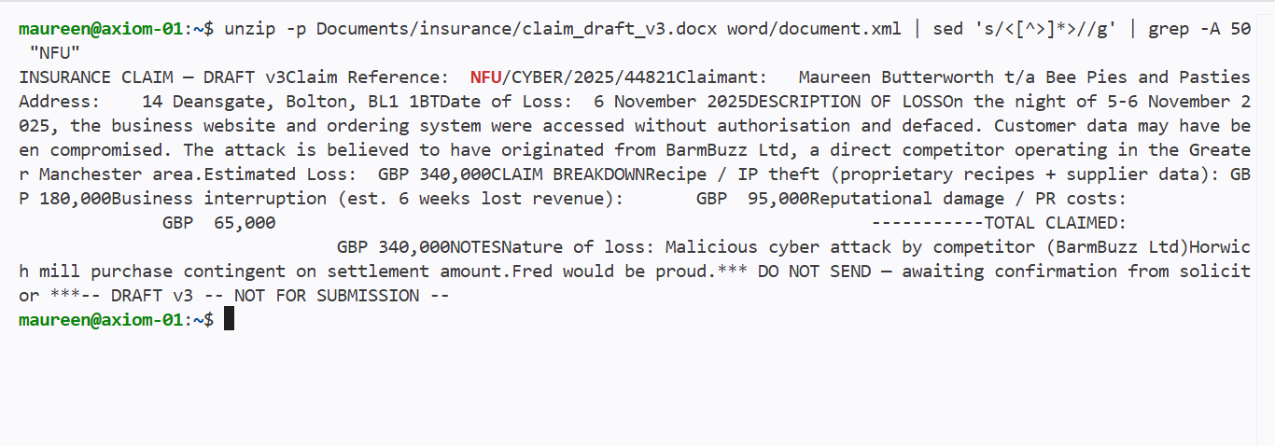File: /home/maureen/Documents/insurance/claim_draft_v3.docx
Command /Tool used: unzip -p … | sed … | grep
Key content:
- Claim reference: NFU/CYBER/2025/44821
- Date of loss: 6 November 2025
- Amount claimed: £340,000
- Internal note: “Horwich mill purchase contingent on settlement amount.”
What it proves: Maureen filed a fraudulent insurance claim on the same day as the attack, seeking money to buy a property which suggests a direct financial motive.
- This seems to be fraudulent for a small business to be asking for an insurance claim of that amount.
Email – Darren away, Maureen in charge
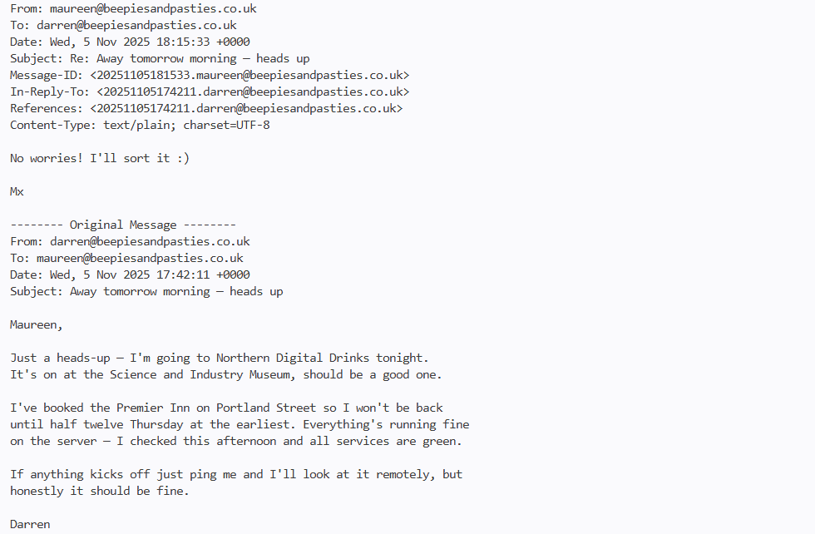

File: /home/maureen/mail_archive/darren_away.eml
Tool used: cat /home/maureen/mail_archive/* 2>/dev/null (also verified with ls -la /home/maureen/mail_archive/)
Key content (from the email):
- Darren writes: “I won't be back until half twelve Thursday at the earliest.”
- Maureen replies: “No worries! I’ll sort it :)”
What it proves:
Darren Webber was absent during the attack window (early morning of 6 November 2025). Maureen confirmed she would take responsibility for the server. This establishes opportunity and positions Maureen as the only person with system access and authority during the incident.
Pcap activity – the access to an internal network, and simple searches:
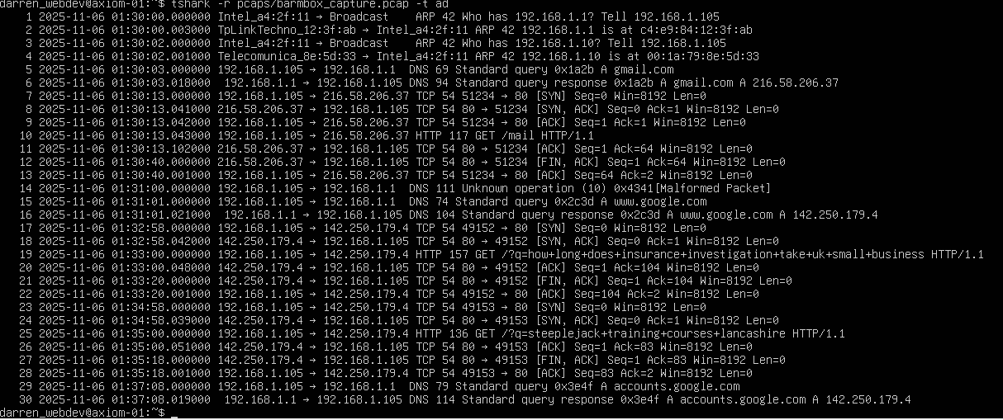
The packet capture shows that the attacking IP (192.168.1.105) made normal web searches, but at 01:33:00 it performed a suspicious search for “how long does insurance investigation take UK small business”. More importantly, frame 14 of the capture contains a UDP packet that decodes to: CAPTURE_META: SSID=bpbpies-Staff SIGNAL=-42dBm LOCATION=inside_bakery. This proves that the attacker’s device was physically inside the bakery and connected to the staff Wi-Fi.
Bash history – initial attacker commands using (darren_webdev account)
File: /home/darren_webdev/.bash history
Tool used: cat
Successful commands:
• cat config.py – read secrets (SECRET_KEY, DB_PASSWORD, admin email).
• df -h – saw disk 98% full (potential DoS).
• git log --online -10 – saw Maureen’s commits (.env added then deleted).
• cd /opt/bpbpies – moved into the app folder.
• git status – saw config.py was modified.
• (presumably) git diff config.py – showed a deleted comment line.
Failed commands:
• All sudo commands – failed because darren_webdev has no sudo rights (good least privilege).
• python3 -c "from app import app; print('OK')" – failed with ModuleNotFoundError: No module named 'flask' (attacker did not activate venv, showing limited technical knowledge).
Proves: The attacker used the darren_webdev account, performed reconnaissance, attempted privilege escalation (failed), and lacked basic deployment knowledge.
Maureen’s own account – privilege escalation and Git commits
User account: Maureen (listed in /etc/passwd, member of sudo and docker groups).
File: /home/Maureen/.bash_history
Relevant commands (timestamps confirm 6 November 2025):
- sudo cat /etc/shadow – reads password hashes (privilege escalation).
- git config user.name "maureen_bpboss" – identity manipulation.
- git commit -m "add env config" – adds .env with AWS keys (containing mAUReen).
- git commit -m "update homepage" – replaces homepage with Barmbuzz notice.
- git rm --cached .env and sudo rm .env – cover-up.
- history -c – clears history.
Auth.log evidence:
Nov 6 01:47:22 axiom-01 sudo: maureen : TTY=pts/0 ; COMMAND=/usr/bin/cat /etc/shadow
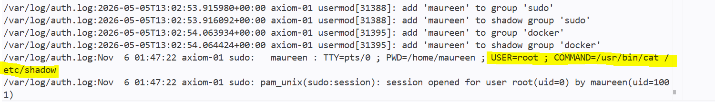
What it proves: Unlike darren_webdev, Maureen had sudo rights. She used her own account to escalate privileges and to commit fraudulent changes directly. This solidifies her as the attacker, not just someone who could be using a shared account.

DHCP lease – ties IP to Maureen’s laptop
File: /etc/dhcp/leases/bakery-lan.txt
Tool used: cat
Key line (from your evidence):
8c:8d:28:a4:2f:11 192.168.1.105 MAUREEN-LAPTOP 2025-11-06 01:30:00 2025-11-06 02:45:00 expired
What it proves: The attacker’s IP 192.168.1.105 (used in the PUT /index.html) was assigned to Maureen’s laptop during the entire attack window.
Packet capture – searches and physical location
File: /home/darren_webdev/pcaps/barmbox_capture.pcap
Tools used: tshark
Findings (from tshark output):
HTTP GET from 192.168.1.105 to Google:
how long does insurance investigation take UK small business (01:33)
steeplejack training courses Lancashire (01:35)
Frame 14 decodes to: CAPTURE_META: SSID=Bpbpies-Staff SIGNAL=-42dBm LOCATION=inside bakery
What it proves: Maureen’s device was physically inside the bakery on staff Wi Fi, and she researched insurance investigation duration and steeplejack training – both supporting the fraud narrative.
Git commit history – Maureen’s actions
Command: git log --all
Relevant commits:
- 0b04a05 (01:52:07) – update db config
- 592874a (01:58:43) – add env config (added. env with AWS key containing Maureen)
- 8bd5c38 (02:16:33) – update homepage (added BarmBuzz acquisition notice)
- 9ec5812 (02:18:47) – remove env config (deleted .env)
Proves: All points Maureen made four Git commits within a 26-minute window on the day of the attack, including adding and then deleting cloud credentials

2.4 Cross-Role Examination
Based on the nature of the attack we have found throughout the system, our team believe to have found evidence and deliberate attack made by the business owner (Maureen). This can be shown throughout the evidence in the system:
1. The insurance documentation was not meant to be shown
The document contains a note: Do not share
the document was draft of the insurance claim which states Barmbuzz as its attacker, but this claim was made way too early without evidence. The amount also seems suspicious whilst the draft was found without Maureen’s personal files.
2. The README gives Maureen both access and motive
The file is titled “Handover notes for Maureen” – she is the owner and responsible for the website during the BarmBuzz acquisition.
She could have added the .env file and later deleted it to sabotage the handover.
Her personal password and her Git commits make her the prime suspect.

3 Final Declarations

3.1 Governance of Business Operations (Governance lead)
Based on the vulnerabilities that were identified in the Bee Pies & Pasties environment, several UK statutes may have been breached:
1. Computer Misuse Act 1990.
Relevant because:
- Unauthorised access to the server occurred.
- Files were modified.
- Bash history and git activity shows the actions may not have been authorised.
- Credentials were stored insecurely, enabling unauthorised access.
Why this matters:
The CMA focuses on unauthorised access and misuse of computer systems. This is directly relevant to the technical failures observed.

2. Data Protection Act 2018 / UK GDPR Article 5 and 32.
Relevant because:
- Personal data was stored outside its intended purpose.
- Customer data was stored insecurely.
- No access control policy existed.
- No monitoring or logging controls were in place.
- Hardcoded credentials and weak authentication.
Why this matters:
This is a regulatory compliance failure, not a criminal prosecution problem. The business must understand their legal obligations and potential exposure.

3. Fraud Act 2006.
Relevant because:
- An insider intentionally altered data.
- Someone attempted to gain financially.
- Misuse of position occurred.
Why this matters:
This is not something that’s proven, but governance requires acknowledging the risk. Speculating guilt isn’t part of it, however identifying the legal framework is.

3.2 Conclusion (Network and Threat Modelling Lead)
The investigation has examined system logs, user accounts, Git history, packet captures, and files stored on the server. The evidence consistently shows that the cyber incident on 6 November 2025 was not an external attack but an internal action.
The DHCP lease table records that IP address 192.168.1.105 was assigned to a device named MAUREEN-LAPTOP during the attack window (01:30–02:45 UTC). The same IP sent a PUT /index.html request at 02:14:11. Bash history from the Maureen account contains commands that read /etc/shadow, altered Git authorship, added and later deleted an .env file with AWS keys, and cleared command history. An email shows that Darren Webber was away overnight, and Maureen responded that she would handle any issues. A packet capture from the same IP reveals searches for insurance investigation timelines and location data placing the device inside the bakery. A draft insurance claim dated the same day claims £340,000, with an internal note linking the payout to a property purchase.
No evidence points to an external attacker. The technical misconfigurations (debug mode, hardcoded credentials, weak password policies) existed, but the attack did not exploit them for initial access – instead, legitimate credentials were used. Based on the combined evidence, the most reasonable conclusion is that Maureen Butterworth, the business owner, staged the incident to file a fraudulent insurance claim.

3.3 References
CWE. (2026) CWE-259: Use of Hard-Coded Password. [Online] Available From: https://cwe.mitre.org/data/definitions/259.html. [Accessed 12 May 2026].
GDPR. (2018) Art. 32 GDPR – Security of Processing. [Online] Available From: https://gdpr-info.eu/art-32-gdpr/. [Accessed 8 May 2026].
GDPR. (2013) Art. 4 GDPR – Definitions. [Online] Available From: https://gdpr-info.eu/art-4-gdpr/. [Accessed 18 May 2026].
GDPR. (2018) Art. 5 GDPR – Principles Relating to Processing of Personal Data. [Online] Available From: https://gdpr-info.eu/art-5-gdpr/. [Accessed 18 May 2026].
GDPR. (2013) Art. 33 GDPR – Notifications of a Personal Data Breach to the Supervisory Authority. [Online] Available From: https://gdpr-info.eu/art-33-gdpr/. [Accessed 8 May 2026].
Gupta, M. (2021) Abusing search permissions on Docker directories for privilege escalation. [Online] Available From: https://labs.withsecure.com/publications/abusing-search-permissions-on-docker-directories-for-privilege-escalation. [Accessed 24 May 2026].
owasp.org. (2021) A05:2021 – Security Misconfiguration. [Online] Available From: https://owasp.org/Top10/2021/A05_2021-Security_Misconfiguration/. [Accessed 16 May 2026].
Schmidt, J. (2024) Understanding the Docker USER Instruction. [Online] Available From: https://www.docker.com/blog/understanding-the-docker-user-instruction/. [Accessed 21 May 2026].
Secure Sauce. (2025) Code Injection in Flask App Config. [Online] Available From: https://docs.securesauce.dev/rules/PY507. [Accessed 20 May 2026].
UK Government. (1990) Computer Misuse Act 1990. [Online] Available From: https://www.legislation.gov.uk/ukpga/1990/18/contents. [Accessed 1 May 2026].
UK Government. (2006) Fraud Act 2006. [Online] Available From: https://www.legislation.gov.uk/ukpga/2006/35/contents. [Accessed 10 May 2026].

